|  |  |  |
| --- | --- | --- |
|  |  | **Your Answer** |
| **Team Name:** |  | TEAM INFELICIS |
| **Category:** | SOFTWARE | SOFTWARE |
| HARDWARE |
| **Team Status:** |  |  |
| **Select the participation type for which the team is selected for further rounds for SIH 2023 (Based on selection they will see the respective challenges or themes)** | This Team will compete for the problem statements listed on SIH 2023 portal | This Team will compete for the problem statements listed on SIH 2023 portal |
| This team will compete for the student Innovation ( team will submit their own idea against any of listed themes) |

|  |  |  |  |  |  |
| --- | --- | --- | --- | --- | --- |
| **Student Full Name**  **Max 200 CHARACTERS** | **Email** | **Mobile** | **Gender** | **Stream** | **Academic Year** |
| Punnayan Saha | punnayan79@gmail.com | 7085455760 | M | CSE | 3rd |
| Diptanil Paul | Diptanil.paul.udp@gmail.com | 9366267751 | M | CSE | 3rd |
| Archishman Ghosh | Archishman2002@gmail.com | 7085163676 | M | CSE | 3rd |
| Pranjit Roy | roypranjit03@gmail.com | 9863728286 | M | CSE | 3rd |
| Rimi Saha | Saharimi518@gmail.com | 708541970 | F | CSE | 3rd |
| Debadrita Dey | Debraditadey08@gmai.com | 7005328758 | F | CSE | 2nd |

I declare that all the information stated above are true as per my knowledge and I follow the sequence of names as per the SIH 2023 student consent letter submitted by me earlier.

N.B: ***SUBMIT IT USING MS WORD***

Team Leader Name : Punnayan Saha

Signature (Digital) :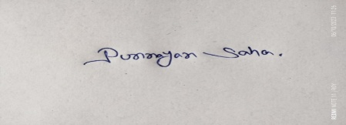

Phone No:7085455760

Whatsapp No:7085455760

Email. Id:punnayan79@gmail.com